## **Project “Shadowed Planet” 1-Page GDD**

*Brief Summary or Hook*

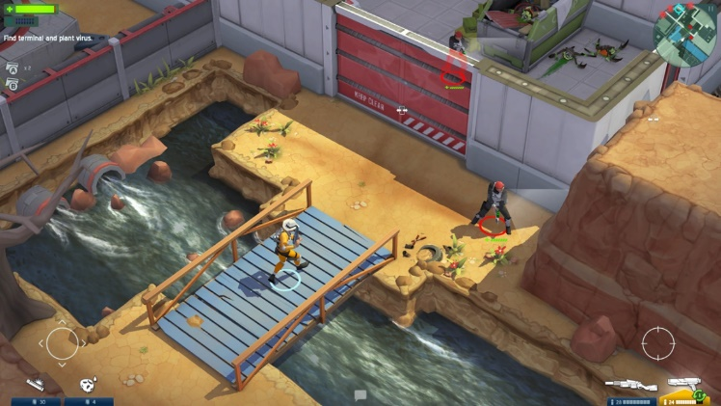 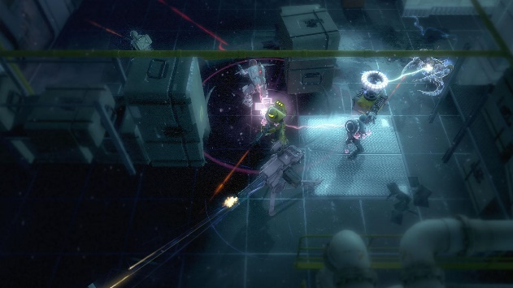

**Genre:** RPG, 3rd person fixed camera RPG  
**Target Audience:** +16

**Controls:** Mouse & Keyboard, Gamepad

**Thematic Setting:** Fantasy, Futuristic, Space

**Tech Stack:** Unity 2018

**Platform(s):** PC

**Game Moment:** Your mission is to recover the documents where tells where is the enemy main base. In all the way through, you will find different types of enemies who are guarding the zone and those documents, and you will have to face those enemies giving you a combat moment.

**Game Summary:** The planet is under attack. Enemies from outer space are invading the planet to conquer it. All hope relies upon a trained agent who is called by the Armed Forces to stop them. You will play as the trained agent, and you will have to pass through different areas, zones and bases to save the planet.

**Core Player Experience:** Action, stealth, darkness, adrenaline.

**Central Theme:** Save the planet.

**Design Pillar:** Face enemies directly or in stealth mode.

**Anticipated Remarkability:**

**Anticipated Steam Early Access Launch date:**

**Feature Development Priorities:**

* Combat enemies with different types of weapons.
* Level design and objectives.
* Player level up.
* Loot items, usable items, inventory.

**Comparative Products:** Space Marshals, Alien Swarm, Alien Breed.